
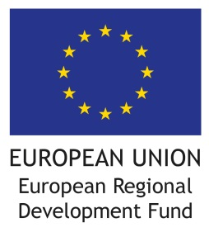
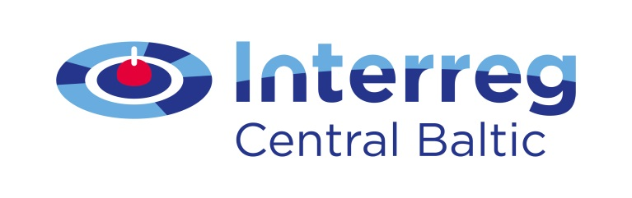


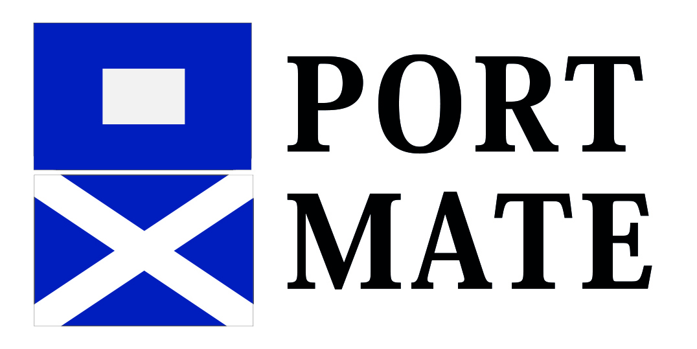
VALUE FOR MONEY!
In these premises you can find an EU-financed project in action.
And not just any project, but a good and interesting one.
Today’s EU projects want you to know what they are all about, so please read on!
The project PortMate: Safely connected and sustainable small ports in Central Baltic region aims at:
The project PortMate will result in:
The project is a joint cooperation venture of:
1) Improving safe access and arrival to, stay in and departure from the port to support less experienced seafarers and take into account nature factors (weather, shallow and rocky routes),
2) Investing in sustainable resource efficient services in ports,
3) Supporting marketing activities by mating the pilot small ports with the sailing triangle from Rauma, FI through Sottunga and Kökar, ÅX to Gävle−Söderhamn region, SE.

1) Formation of interactive step-by-step guidance (ICT solutions) on safety of small ports
2) Investments to sustainable and resource efficient infrastructure on land
3) Mating the small port operators with each other and with seafarers through co-operation activities and marketing.

There will be 19 Central Baltic small ports with improved services by the end of the project.
Satakunta University of Applied Sciences, Finland | City of Rauma, Finland | City of Gävle, Sweden |
City of Söderhamn, Sweden | Municipality of Sottunga, Åland |Kökar Havspaviljong, Åland
This is done with € 2.045.418,62 from the European Regional Development Fund.
Find out more:
Project leader, research manager Minna Keinänen-Toivola, Ph.D.
(minna.keinanen-toivola@samk.fi)
www.facebook.com/cbportmate |

